Lab Session – Day 6

**Question:**

Use ExcelR (Create a database if not created). Create a students table with following fields and constraints.

* Roll_No (No null values + should be unique)
* Name (No Null values accepted)
* Age (Should accept only values ranging 5 to 15)
* Parents_Email (Should be unique)
* Address (If no address is mentioned then it should show “-“)

Enter the data as shown in output image below.

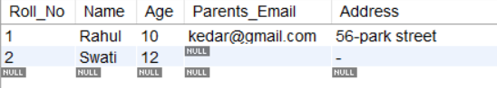

**Solution:**

Write the below query in MySQL workbench.

